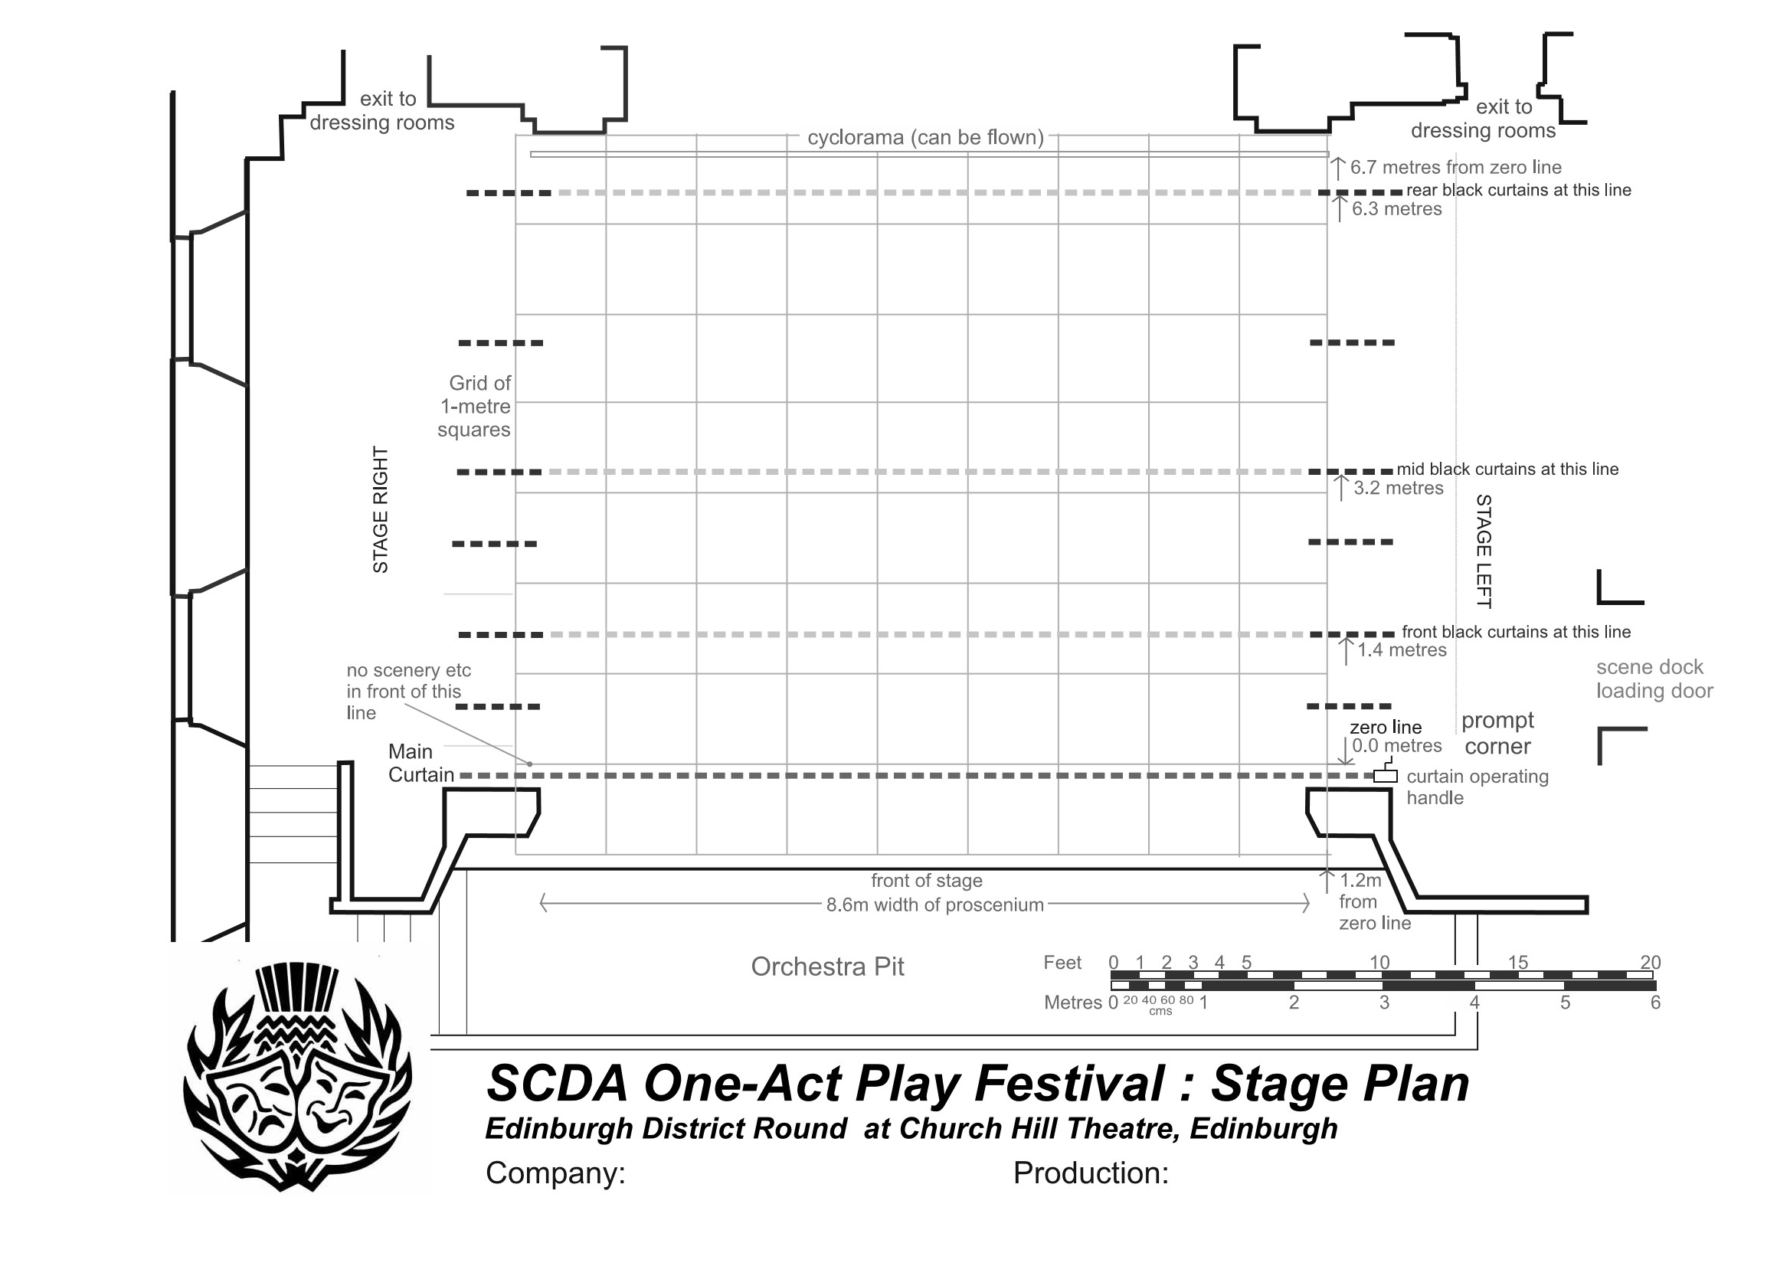

scene

dock

loading

door

0

6